Take the Nellie Bly Quiz 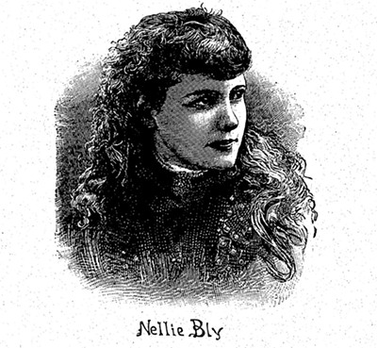How well do you know Nellie Bly, the intrepid reporter who blazed a trail for women in journalism at the turn of the twentieth century? Take the quiz!
Answer each question. Give yourself a point for every answer you get right, then see what category you fall into at the end of the quiz!

- Nellie was born into a wealthy family
- True
- False

- What was Nellie’s childhood nickname?
  - Pink
  - Squirt
  - Puddin’

- What scandalous thing did Nellie’s stepfather, Jack Ford, do?
  - He stole money from a bank
  - He tried to shoot Nellie’s mother
  - He had an affair with Nellie’s mother’s best friend

- Why did Nellie change the spelling of her surname from Cochran to Cochrane?
  - Her mother demanded it if she wanted to be a reporter
  - To distance herself from her tumultuous years in her hometown of Apollo
  - She didn’t. It was a typo she never corrected.

- What, related to Nellie, was featured in the New York World’s time capsule of Oct 9, 1889?
  - A reprint of her famous asylum exposé she wrote 2 years earlier
  - A photograph from her around-the-world stunt that made her internationally famous
  - A front-page story she wrote with her byline

- How many years did Nellie trim off her age when filling out her passport in 1888?
  - Two
  - Three
  - Four

- A few years after her Blackwell’s asylum exposé, Nellie was rumored to be engaged to Frank Ingram, one of the Blackwell’s asylum doctors
  - True
  - False

- What exotic animal did Nellie return home with after her around-the-world trip?
  - A parrot
  - A Siamese cat
  - A monkey

- What do some historians believe was the reason for the World’s lukewarm reception of Nellie upon her return to the United States after her race around the world?
  - A hushed-up libel suit that arose about a story she’d written
  - Joseph Pulitzer was unhappy with her final race time
  - The World had heard rumors she was going to go to a competitive paper

- What was the grand prize the New York World offered to the person who guessed Nellie’s race time, down to the second?
  - A trip to New York City to meet Nellie
  - Dinner with Nellie and Joseph Pulitzer
  - A trip to Europe and spending money

- Why did a train Nellie once took nearly crash into a canyon?
  - It was going too fast
  - It was under construction
  - It was a wild rumor. Nellie was never in any danger!

- What was the name of the novel Nellie wrote in 1888?
  - The Mystery of the Disappearing Woman
  - The Mystery of the Gold Treasure
  - The Mystery of Central Park

- Whom did Nellie marry in 1895?
  - A newspaper publisher ten years her senior
  - An industrialist 30 years her senior
  - A millionaire 40 years her senior

- Nellie was among just two other female reporters at Joseph Pulitzer’s funeral
  - True
  - False

- What item did Nellie have that was once owned by Queen Victoria?
  - A letter
  - A tiara
  - A brooch

- What president did Nellie write to requesting a private meeting?
  - Woodrow Wilson
  - Theodore Roosevelt
  - William Howard Taft

- What was Nellie once arrested for?
  - Failing to produce documents in court
  - Inciting a riot at the 1913 women’s suffrage rally in Washington, DC
  - Nellie was never arrested

- What did Gordon Fawcett Hamby send Nellie before he was sentenced to be executed in 1920?
  - His last will and testament
  - A letter and a Outja board
  - Thirty dollars and a gold ring

- What did Nellie say was one of the best days of her life?
  - The day she married her only husband, Robert Seaman
  - The day she hosted a picnic for 750 orphans in Brooklyn
  - The day she rode a horse in the women’s suffrage rally in Washington, DC

- Sadly, Nellie was buried in an unmarked grave for how many years?
  - Twenty
  - Forty
  - Fifty

Answer Key:
1. a 2. a 3. b 4. b 5. c
6. b 7. a 8. c 9. a 10. c
11. b 12. c 13. c 14. b
15. c 16. a 17. a 18. b
19. b 20. c

How did you do?

1-10 points
You need to brush up on your Nellie! This brave woman accomplished so many groundbreaking things in her short, fifty-seven years.
11-15 points
You’re a Nellie aficionado! Congrats. Give yourself a pat on the back for knowing some of the smaller details of her fascinating life.
16-20 points
Bravo, you’re a Nellie expert! You’ve likely read up on the incomparable reporter and know more than the average joe. Well done!

For details behind the questions and answers above, see the following posts on my blog, The Deeper Story:
https://www.tonyamitchellauthor.com/post/ten-little-known-facts-about-nellie-bly
https://www.tonyamitchellauthor.com/post/ten-more-little-known-facts-about-nellie-bly

